Assignment 08:

Use sub-query to solve following problems.
Note: To solve below queries, use “sales” database

- Write a query that uses a subquery to obtain all orders for the customer named Cisneros. Assume you do not know his customer number (cnum).

SELECT * FROM orders
WHERE cnum =ANY(SELECT cnum FROM customers
WHERE cname = ‘Cisneros’);
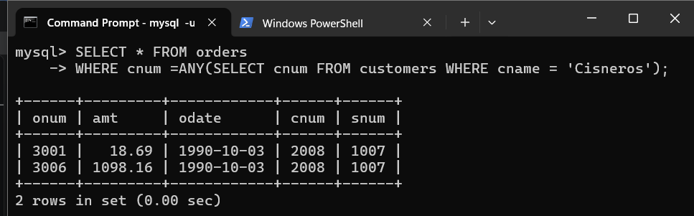

- Write a query that will find all salespeople who have no customers located in their city. (Hint: Choose the correct keyword ANY/ALL).

SELECT s.sname, s.snum, s.city
FROM salespeople s
WHERE s.snum <>ALL(SELECT c.snum
FROM customers c WHERE s.city = c.city);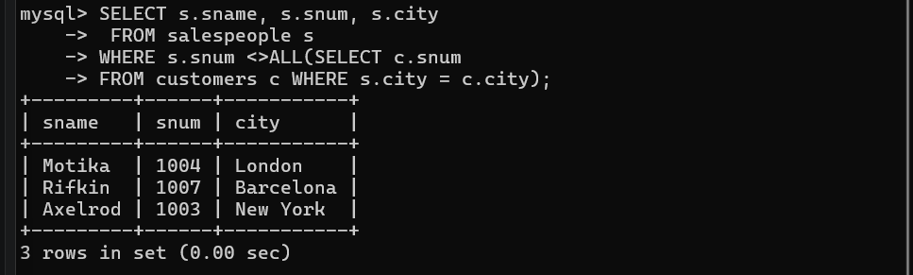

- Extract all the orders of Motika.

SELECT * FROM orders
WHERE snum = (SELECT snum FROM salespeople
WHERE sname = 'Motika');
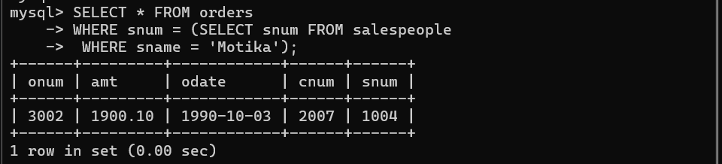

- Find all the orders of salespeople servicing customers in London.

SELECT * FROM orders
WHERE snum =ANY(SELECT snum FROM salespeople
WHERE city = ‘London’);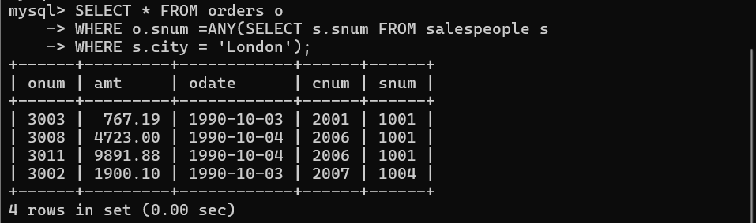

- Find names and numbers of all salesperson who have more than one customer.

SELECT sname, snum FROM salespeople
WHERE snum =ANY(SELECT snum FROM customers
GROUP BY snum
HAVING COUNT(cnum) > 1);
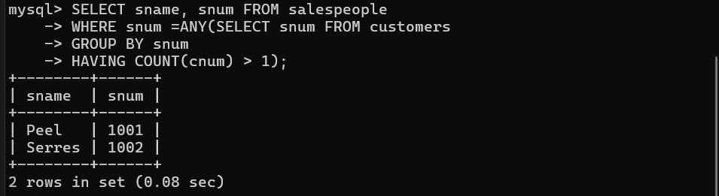
- Select customers who have a greater rating than any other customer in Rome.

SELECT * FROM customers
WHERE rating >ANY(SELECT rating FROM customers
WHERE city = ‘Rome’);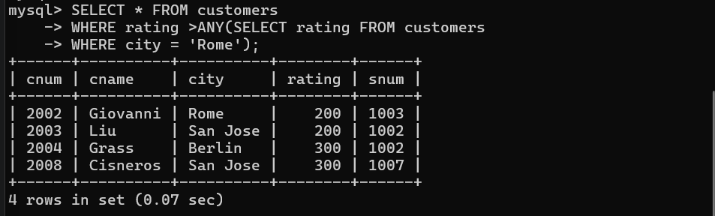

- Select all orders that had amounts that were greater than at least one of the orders from ‘1990-10-04’.
SELECT * FROM orders
WHERE amt >ANY(SELECT amt FROM orders
WHERE odate = ‘1990-10-04’);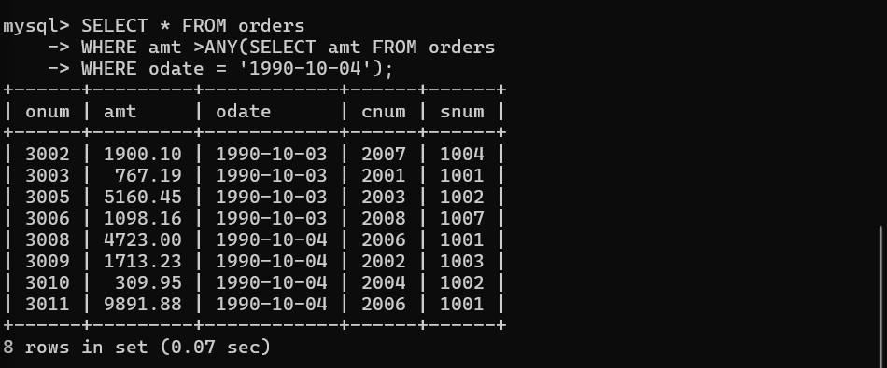

- Select those customers whose rating are higher than every customer in London.

SELECT * FROM customers
WHERE rating >ALL(SELECT rating FROM customers
WHERE city = ‘London’);



